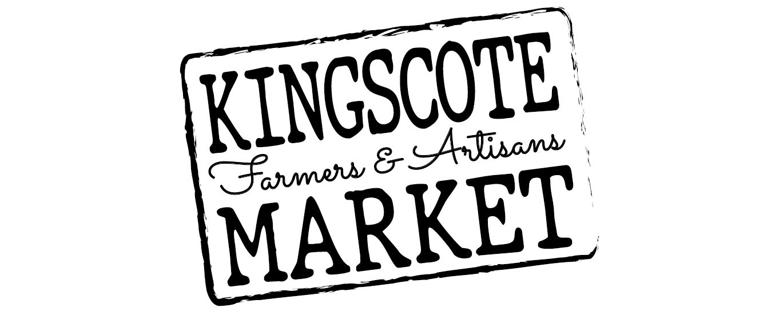

Rules and Responsibilities
(Effective as of August 17th 2023)

1. THE KINGSCOTE FARMERS & ARTISAN MARKET

The Kingscote Farmers & Artisan Market (KFAM) has a vision for Kangaroo Island to have a thriving, localised economy of producers and creators. We will achieve this by cultivating a vibrant, sustainable, community minded market that drives the demand for and supply of produce and products grown and created on Kangaroo Island.

We value:
- Fresh, locally grown, seasonal produce;
- High quality, value-added products that are created on Kangaroo Island;
- Sustainable practices that protect and restore our natural environment; and
- Our community and providing them with a market that is welcoming and family friendly.

KFAM Committee:
An elected committee operates the Kingscote Farmers & Artisan Market (KFAM) and ensures compliance with the Code of Practice, in accordance with the KFAM constitution. The Committee is responsible for the strategic management, control of funds and other property of the market, as well as the general running of the market on market days and the integrity of the market as a whole.

2. TRADING AT THE MARKET

STALLHOLDER ELIGIBILITY:
In order to establish a stall at the KFAM, each stallholder should complete an application form to be approved by the Committee prior to their first market. It is also a requirement of stallholders to be a member of KFAM so if not already, a membership form and payment will need to accompany your application.

ALLOWABLE PRODUCT AND SALES:
KFAM encourages stallholders to sell handcrafted, artisan, and locally grown and produced products from Kangaroo Island. Exceptions to this, and only where approved by the Committee are:

- Those selling a commercially produced product provided that 50% of their items for sale are locally made or value-added product.

- Stall holders not residing on Kangaroo Island may be approved if they are offering a service or product that is not currently available locally. In addition to this, any stallholders with non locally produced products must provide written evidence of how their product is beneficial to Kangaroo Island.

The stallholder may sell only product that has been approved by the KFAM Committee, and any additional products once application has been processed, must be approved by the Committee prior to selling. All primary produce is to be grown on Kangaroo Island or clearly stated where it has been grown and producers must be able to state their growing methods including if pesticides are used etc.

The Committee need to receive a completed application form from each stallholder that needs to be approved before they can attend their first stall. The Committee has final say over approving or declining an application and have absolute discretion to cancel any application, by a new or existing stallholder, to operate a stall at KFAM for misconduct or unco-operative behaviour.

On occasion the Committee will allow Guest Stall holders that may not meet all the above requirements but is deemed to add value to the market for consumers. These will be reviewed extensively and approved by the KFAM Committee on an individual basis.

KFAM encourages stalls from community groups, however these must be non-political and non-religious not for profit organisations supporting our community.

STALLHOLDERS SELLING FOOD ITEMS:
It is the responsibility of the individual stall holder to ensure they have met local Council requirements prior to trading – SEE HEALTH AND SAFETY FOR FURTHER INFORMATION ON THIS

For further clarification on any of the above guidelines please contact the Committee at kingscotemarket@gmail.com

3. INSURANCE

For those who have their own insurance they must provide the Committee (via email) with an Insurance Certificate of Currency. The Certificate of Currency must clearly state the stallholder’s trading name and be current.

If you do not hold your own Public Liability Insurance there is an additional fee of $5 required with stall fees each market

It is the stallholder’s responsibility to find out if they need product liability insurance

4. MARKET DAY
The current Market hours are from 10:00am to 1.00pm, and stallholders need to be ready and set up no later than 9:30am. There can be no moving of vehicles within market area between 9.30am and 1.00pm. In the event that you have sold out of your product, you are welcome to pack up and remove any signage or display but need to wait until 1.00pm to take down your marquee and pack up.

STALLHOLDER BOOKINGS:
Prior to each market the stallholders will be contacted by the Committee to confirm their attendance. If attendance is not confirmed then a stall place will not be guaranteed.

STALLHOLDER CANCELLATIONS:
Should you need to cancel once your booking has been confirmed, please notify the Committee as soon as possible to either kingscotemarket@gmail.com

MARQUEE/TABLE HIRE:
Should you need to hire a KFAM Marquee or table, these need to be booked prior to Market day. Packdown and return of any hired or borrowed Marquees, tables and concrete weights are the responsibility of the stallholder.

SITE ALLOCATION:
The location and site boundaries of stalls will be determined by the Committee prior to the day where possible, and stall holders must take guidance on the day from the Committee member in charge of stall allocation. The location of a stall will be determined taking into account stallholder requests and needs, but also in the best interest of the Market Venue (currently The Kingscote Wharf) and the entire Market. KFAM will endeavour to keep regular stallholders in the same position each week but permanent site allocation is not guaranteed. In the instance of poor weather conditions, all stall positioning will be addressed on a case by case basis.

ACCESS TO MARKET SITE:
Access to the Market site for stallholders is 2 hours before the advertised opening time to the public. Stallholders are required to have their stall ready, with all exhibits displayed for sale, by no later than 15 minutes prior to KFAM’s opening time. Stalls must be open, and properly staffed for the entire trading period of the Market. Stalls cannot be dismantled until the close of the Market or unless approval has been given by the Committee. No vehicles can operate in the designated market site during trading hours.

STALL FEES *
Members Stall Hire Fee $25.00 for a 3m x 3m site
Non-members Stall Hire Fee $40.00 for a 3m x 3m site
Additional fees……
Powered Site $5.00 (only tagged and tested power cords are to be used)
Insurance $5.00 if required (otherwise a copy of certificate of currency must be provided)
Marquee hire $10.00 for a 3m x 3m marquee
Table hire $10.00
Membership $25.00 Per annum

*These stall fees will come into effect as of August 17th 2023

The KFAM Treasurer or another committee member will issue an invoice via email for market fees. Stall fees are able to be paid at the market if the treasurer is present and able to process cash or card payment using the Markets ‘Square’ account and or device.

5. SUSTAINABILITY

KFAM encourages the use of reusable crockery and utensils for the consumption of food and drinks and the use of reusable and returnable food ware and containers for food and drink. We aim to eliminate polystyrene containers and food ware where possible.
​
We would like to encourage stallholders to consider the use of compostable containers and foodware manufactured entirely from natural organic materials such as paper/card, wood or cane. These should be certified from sustainable sources. PLA (bioplastic) is another compostable option but it is not preferred due to its propensity to act like a plastic product unless it is commercially composted.

Food Providers and any other stall holder which creates ‘consumer waste’ during the markets are responsible for their customers waste and recycling at all times. This means food providers and stalls which create ‘consumer waste’ must ensure none of their food containers, packaging, etc. are left on tables, the ground etc. during as well as after the market.

Food Providers and any other stall holder which creates ‘consumer waste’ during the markets are required to provide waste bins for their customers. Stall holders are responsible for recycling and disposal of their customers waste off site.
​
6. HEALTH AND SAFETY AT KFAM

All stall holders are required to supply publicly accessible hand sanitiser for consumers

STALLHOLDERS SELLING ANY FOOD PRODUCT
Stallholders must comply with all relevant legislation, including the Food Act 2001 (SA) and Food Regulations 2002, in addition to the Australia New Zealand Food Standards Code and all relevant National Food Safety Standards.

It is the responsibility of each stallholder to apply for any licences or permits required for selling or producing their products to the public. All value-added food goods must be made in a kitchen/food premise approved by the relevant Local Council. You will need to contact the local council for all of the relevant requirements. These forms include but are not limited to the following:
- Food Business Notification Form
- Temporary Food Premises Form
A copy of the licenses/permits/approvals must be given to the Committee with your application.

STALL HYGIENE:
Stallholders are responsible for any and all garbage left at their site and all garbage must be taken with stallholders. Any stall which produces waste through the sale of products or services must provide a public accessible bin for their customers to dispose of the waste the stall has generated.

