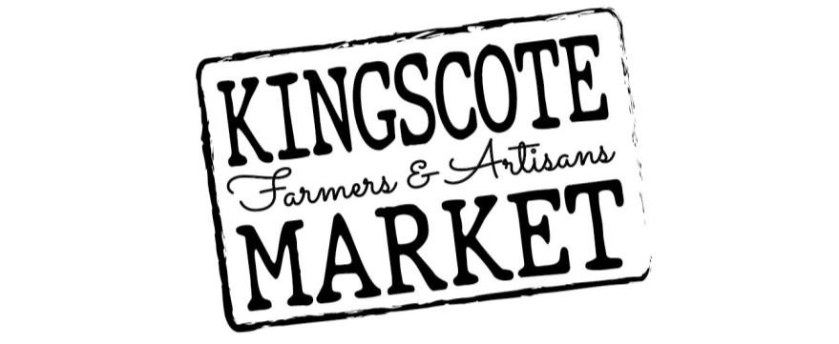
2022/23 Stall Holder Application to Trade
(effective as of August 2022)

By completing this form, you acknowledge your understanding of a stallholders expectations as stated in the Kingscote Farmers & Artisan Market Constitution as well as Rules and Responsibilities involved.

Name of Applicant *………………………………………………………………….......................................
Business/Trading Name* .………………………………………………………………………………………
Registered Business Name ……………………………..……… ABN:………………..……………………
Facebook & Instagram addresses………………………………………………………………………………
Business Address/Location* ……………………………………………………………………………………
Postal Address ….………………………………………………………………………………………………..
Website (if applicable) …..………………………………………………………………………………………
Email* ……………………………………………………………. Phone* ……………………………..
*Information marked with asterix is required to process application

Product/s for sale (all that are applicable):
□ Food - Artisan (pre-packaged/made) | □ Food - Artisan (Prepared on site) | □ Food - Fresh Produce/Honey
□ Food - Preserves | □ Food - Small Goods | □ Food - Meat/Diary
□ Beverages | □ Arts | □ Craft
□ Services (ie hairdresser, facepainting,etc) | □ Other:……………………….. | □ Other: ………………………

Please give a brief description of what items you plan to sell at the Kingscote Farmers & Artisan
Market:………………………………………………………………………………………………………………
…………..……………………………………………………………………………………………………………
…………..……………………………………………………………………………………………………………
…………..……………………………………………………………………………………………………………
…………..……………………………………………………………………………………………………………

CIRCLE WHERE APPLICABLE:
How regularly do you plan to have a stall? [ Every Market ] [ Once a Month ] [ Occasionally ]
Do you require Power? (see Rules & Responsibilities for further information) [ YES ] [ NO ]
Do you have your own insurance? [ YES ] [ NO ]
If yes please provide further details and attach certificate of currency: ..…………………………………….
Do you require a vehicle to stay on your allocated stall site? [ YES ] [ NO ]
If yes please provide further details: ………………………………………………………………………….

What date do you plan to have your first stall at the Kingscote Farmers & Artisan Market: __ /__ /__
If you are selling a food product of any kind, have you:
- Completed a “Food Business Notification Form” and submitted this to Council? YES / NO
- Completed a “Temporary Food Premises Form” and submitted this to Council? YES / NO
- Had your kitchen inspected and certified by Council? YES / NO

*NOTE: As of 25 August 2022, It is no longer a requirement that all stallholders are required to be financial members of the Kingscote Farmers & Artisan Market, but Members will receive a reduced stallholder fee compared to Non-member stallholder fees.

STALL HOLDER DECLARATION:

- I understand that this application does not guarantee me a stall site at the Kingscote Farmers & Artisan Market and that I will receive confirmation once it has been reviewed by the KFAM Committee

- I have read and understood the Rules & Regulations and Constitution. I agree that, should my application be accepted, my approval to occupy a stall at the market is conditional on my compliance with these Rules & Regulations and that my application can be cancelled should I not adhere to these

- I confirm that the information I have provided is true and accurate and understand that this information will be used for the Kingscote Farmers & Artisan Market administration

Applicant Name …………………………………………………………
Signature………………………………….

Stall Name ……………………………………………………………….... Date __ / __ / __

PLEASE COMPLETE THIS FORM, and EMAIL or POST BACK A COPY

OFFICE USE ONLY  Date Received: ………………….. | Processed By: ………………….. | Date Approved/notified: …………..……..

