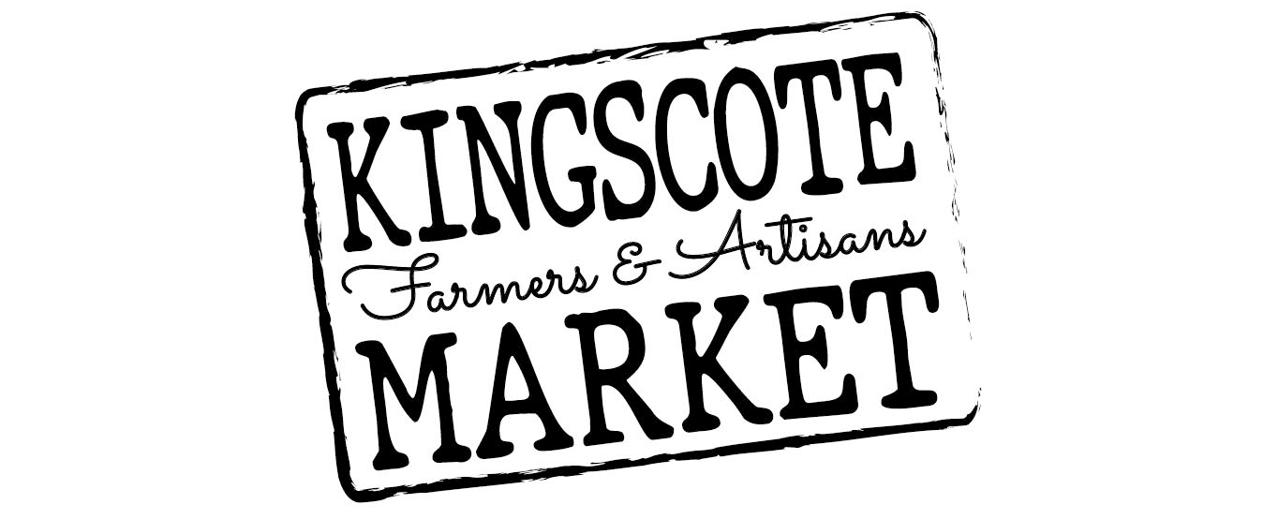

2022/23 Annual Membership Application
Our market is a not-for-profit organisation,
run by the community, for the community.
By becoming a member of the Kingscote Farmers & Artisan Market you are making a valuable contribution to your local community and helping us provide many local small businesses with a place to trade.

Membership benefits include:
- Members receive a discounted Stall Holder fee of $20.00 per market
- Non-Member stallholder fees are $40.00 per market
- The ability to nominate and vote at the KFAM AGM
- The ability to be part of the KFAM committee
Membership cost is $30 per Business/person, per year and this form can be dropped off with payment at the market on the 2nd or 4th Sunday of the month, posted to P.O. Box 487 Kingscote, SA 5223, or emailed to kingcotemarket@gmail.com for an invoice to be sent back for the membership fee.

Conditions:
- Membership must be paid in full by EFT or in person by cash at the Kingscote Farmers & Artisan Market
- Membership is non-transferable and cannot be used by anyone other than the member
- Membership runs for the financial year
OFFICE USE ONLY
Membership Number________ Date membership commenced __ / __ / __ Payment rec’d __ / __ / __
First Name ……………………………………..…….. Second Name …………………………………………..……….
Postal Address ……….......…………………………………………………………….……………………………………...
City ………………………………………… State…………………..…………… Postcode…………………………..
Email …………………………………………………………………. Phone/Mobile ..…….…………………………….
Membership Type
Stallholder - Farmer Stallholder – Producer/Artisan Community Member

Name/Product of Stall (if applicable) ….…..……………………………………………………………………………..…..
Signed ……………………………………………………………………………. Date ……………………………………
Membership fees can be paid by: cash at the Market or online (using your name as reference) AFTER you have completed the form. You will be notified when your membership card will be available for collection from the Market
ACCOUNT DETAILS: Kingscote Farmers & Artisan Market, BSB: 105 094 Account: 035147540 REF: your full name

